Observations on New Implementation on SSD Selector Tool v2.0.1

1. In Server Type page,

* Need to change the heading, since this page has the combination to select the entity such as

1. To Select the Server Type and Model
2. Capacity
3. Interface
4. In the Interface Type Tab

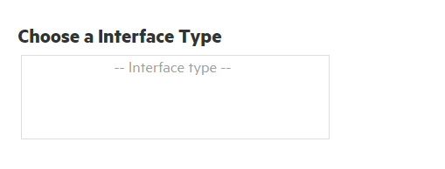,

Tab should be same as Capacity Tab.

1. Text should be at left side. (It should as “SAS, Value SAS, SATA and NVMe) in light mode
2. While selecting the Types of interface should be seen not as “Interface “as a type
3. While selecting the type of interface is shows Green Color after selecting it changes to Blue,

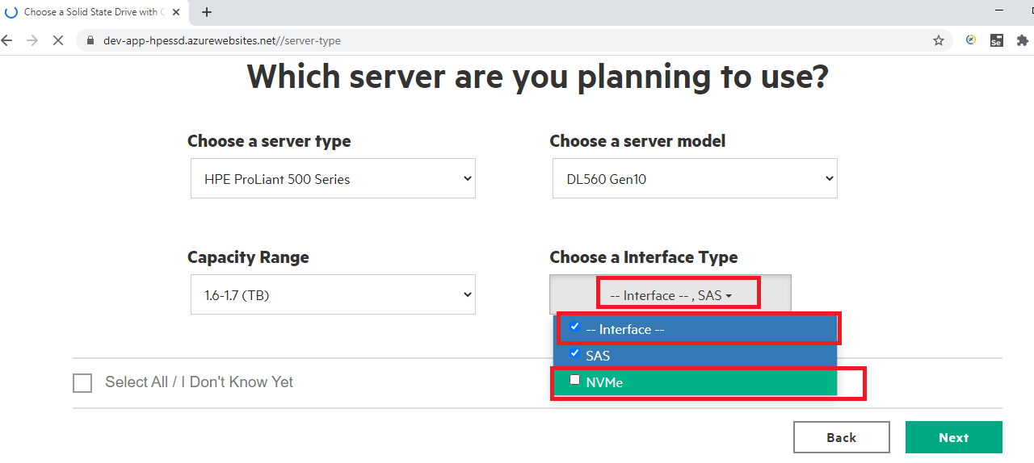

1. Form Factor page is not showing,
   1. While coming from the beginning
   2. Form Factor page displays when clicked on Back in Best Availability Page.
2. In Best Availability Page,
   1. Heading text needs to change.

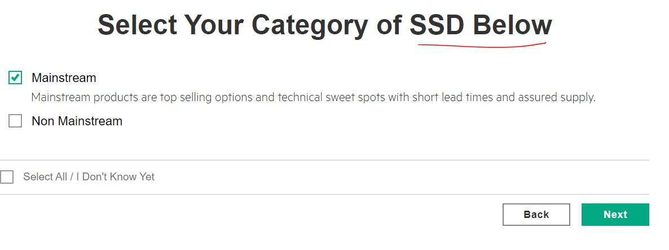

1. In Interface Page, Click on Back it redirects to Home Page.
2. In Result Page, For NVMe,
   1. When both NVMe (High Performance and Mainstream) are in unchecked mode, then NVMe should be unchecked Mode.

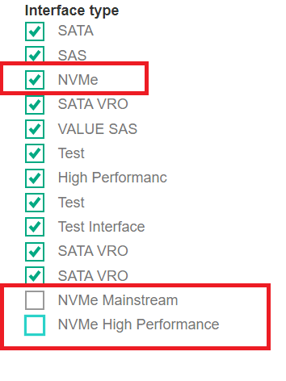

1. In Result Page, Slider for “4K Max Random Read IOPS” then Slider value changes for another slider.

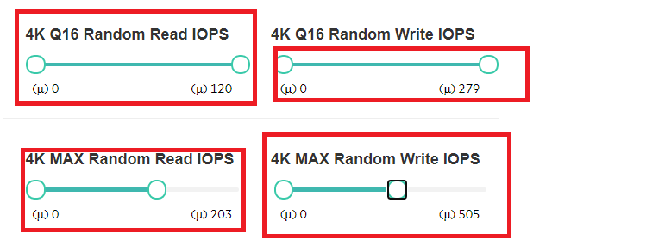

1. In Excel File, we need to add suggested columns

Today Issues

1. Though options are in disabled state, then also Next Button is enabled state.

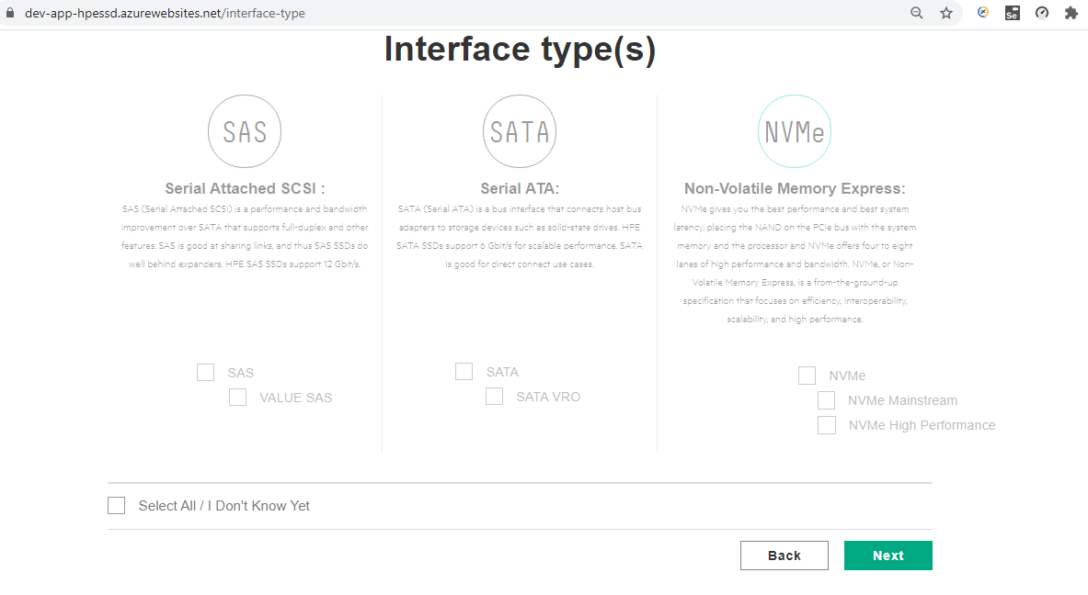

1. In Server Type page, though all options are selected, then also Next is not enabled.

* In Server Type Page, click on “Select All/ I Don’t Know.”
* Again, click on “Select All/ I Don’t Know.”
* Select the Capacity, Server Type and Server Model
* Then Next Button gets disabled state.

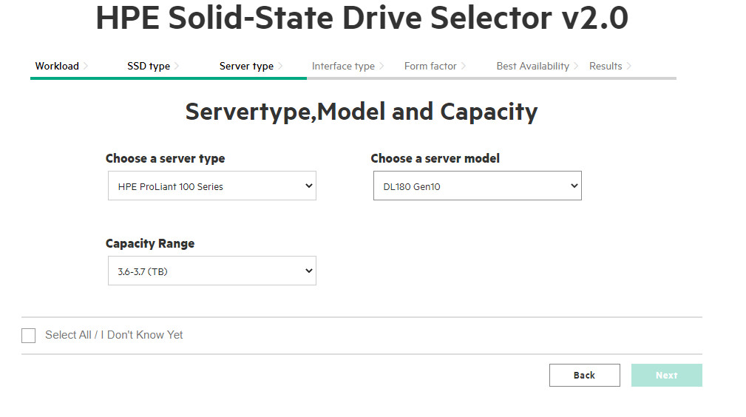

1. Validation is missing in the Interface Type page; Next Button is enabled proceeding pages and No results is displayed.
2. In the Result Page, SSD workload should be displayed in this format,

* Very Read Optimized
* Read Intensive
* Mixed Use
* Write Intensive

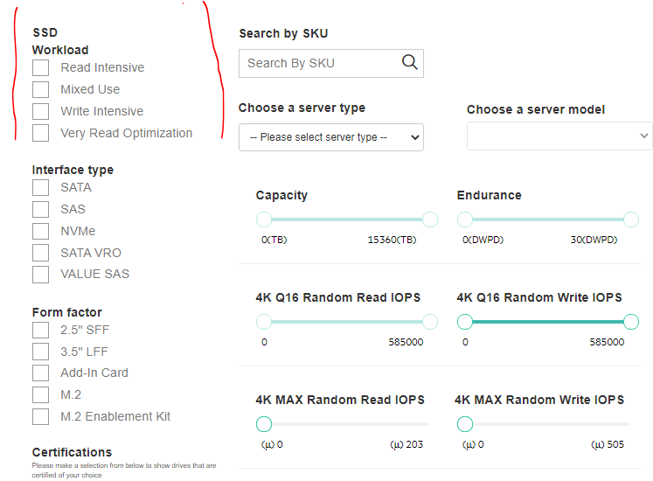

1. “Select All/I Don’t Know” option is selected in all Pages (Workload, SSD and Server Type Page), interface options are not selected.



1. Click on “Back” Button in the Interface Page, then In Server Type page, Next Button is disabled state though “Select All/I Don’t Know” Option is selected

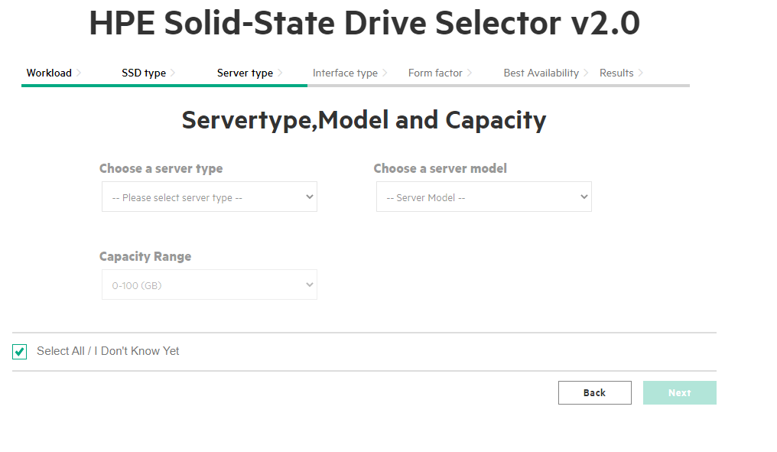

1. In Result Page, when below message appears,

* “There are no results based on your selection. Please select different attributes or Start Over.”
* “Export CSV” should be in disabled state.

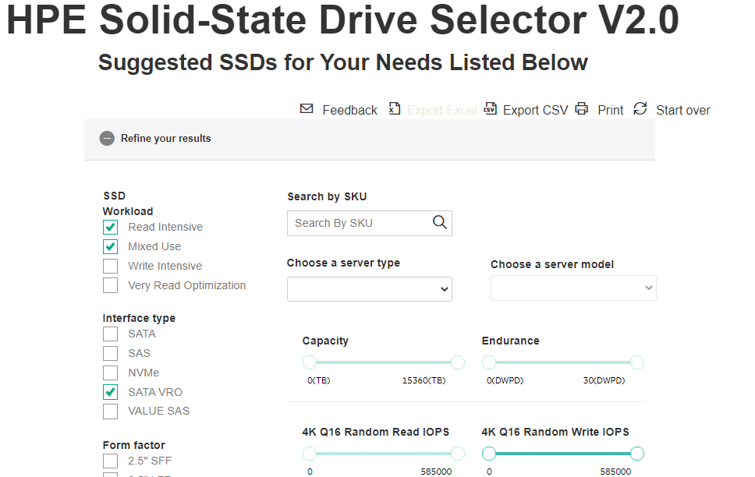

* Then “Export Excel” button gets enabled, though. SSD’s results are not there.

1. 249 SSD’s are displayed, when clicked on “I Know What I Need”.
2. In Result Page, Capacity Slider is not reset to Initial Value when clicked on “**Select All/Un Check All**” option.

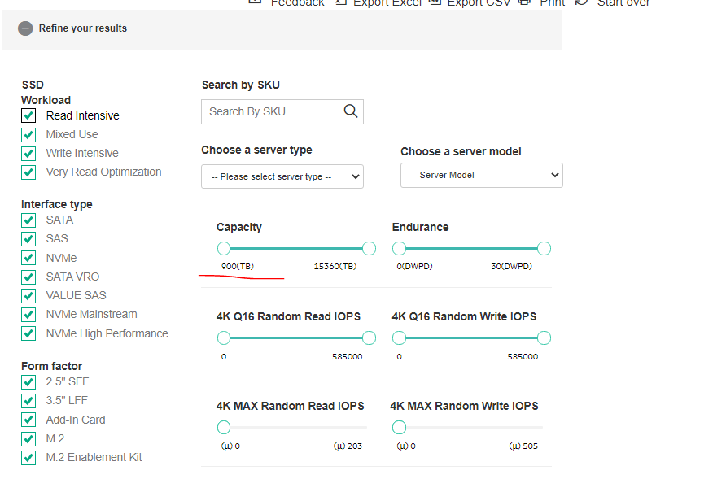

1. In Result page, results are displayed though option is in unchecked for **“NVMe”** Sub elements

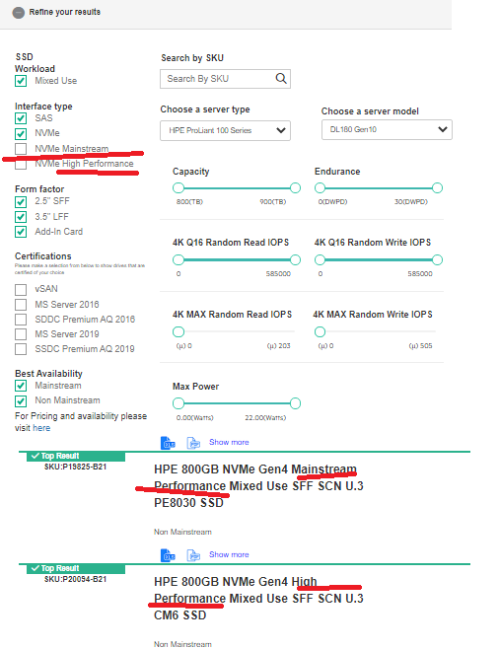

**Today’s Release Issues**

1. In Result Page, In Capacity Slider it is showing 300TB to 400TB, in server type page selected capacity value is 300GB to 400GB.
2. In Result Page, SSDs results are displayed more than capacity value showed in the Capacity Slider/Selected in the Capacity Drop Down in Server type page.
3. In Server Type page and Result page, Server Model List is displayed not based on selected Server type.

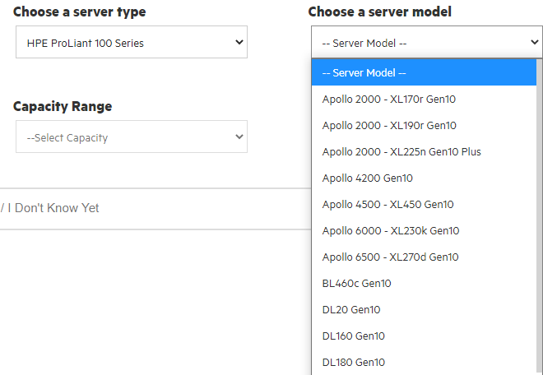

1. In Server Type page, Server Model Tab is enabled before selecting the Server Type.

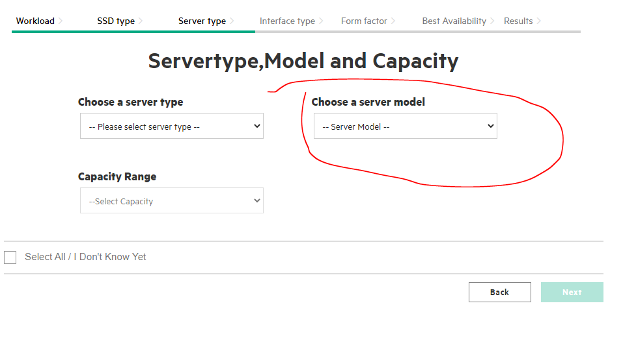

1. Selected Capacity is not shown in the Capacity Tab, on click on “Back” Button in Interface Page,

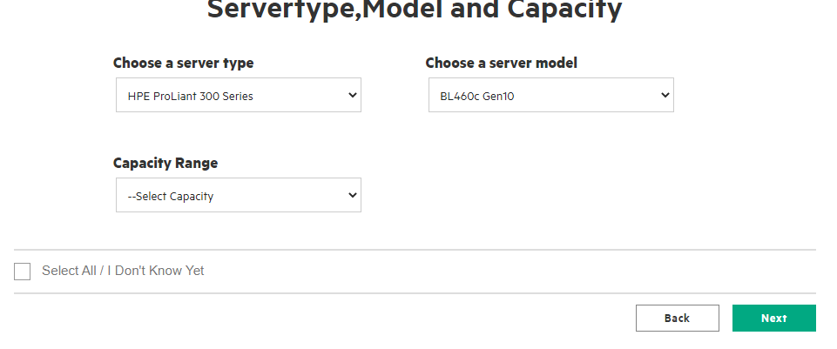

1. In Interface Page, Selected options should be in highlighted State.

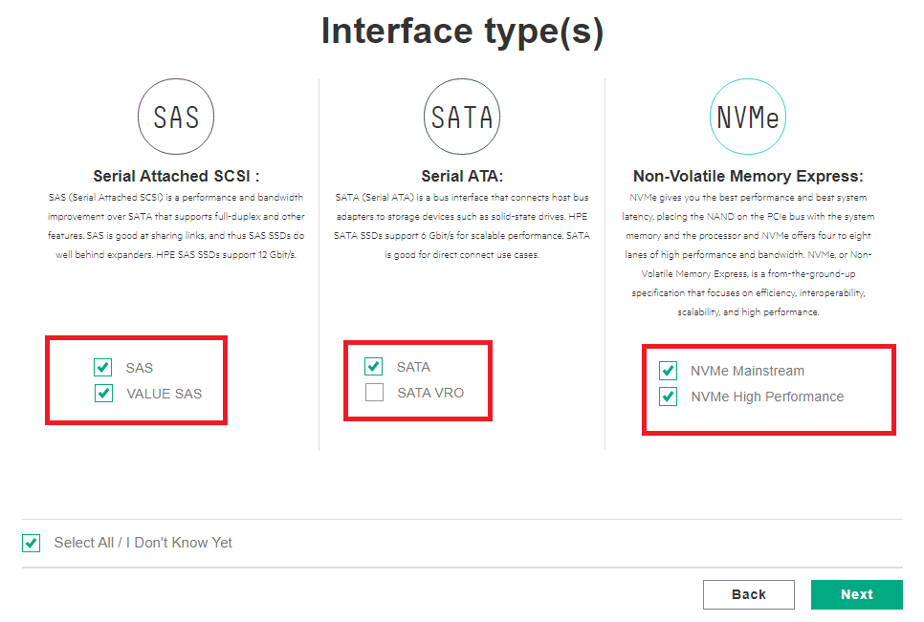

1. In Interface page, “Select All / I Don’t Know Yet” option is not selected.
   1. In Interface Page, deselect the selected checkbox.
   2. Then “Select All / I Don’t Know yet” option will be unchecked mode.
   3. Then Click on Interface options such as “SAS, Value SAS, SATA, SATA VRO, NVMe Mainstream and NVMe High Performance,
   4. Then “Select All / I Don’t Know yet” option should be selected. But it is not selected.

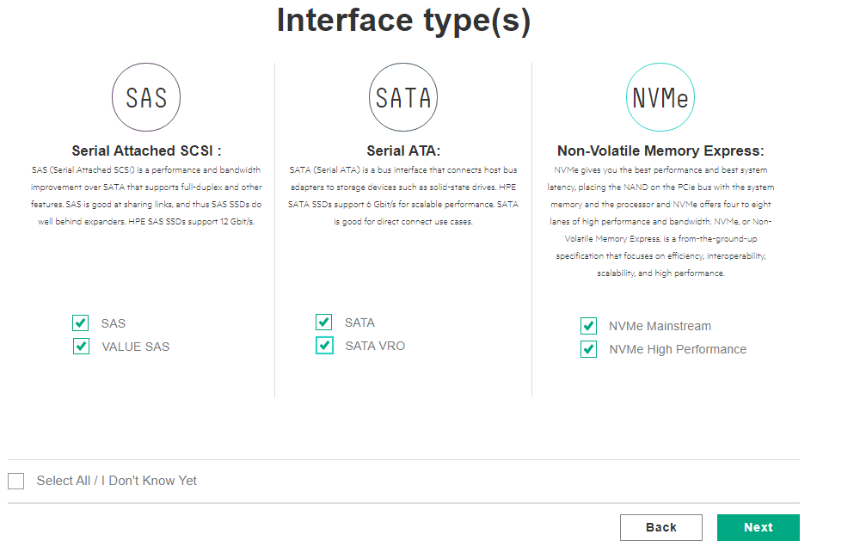

1. In Interface page, “Select All / I Do not Know Yet” option should be unchecked mode, when click on Interface options such as “SAS, Value SAS.”

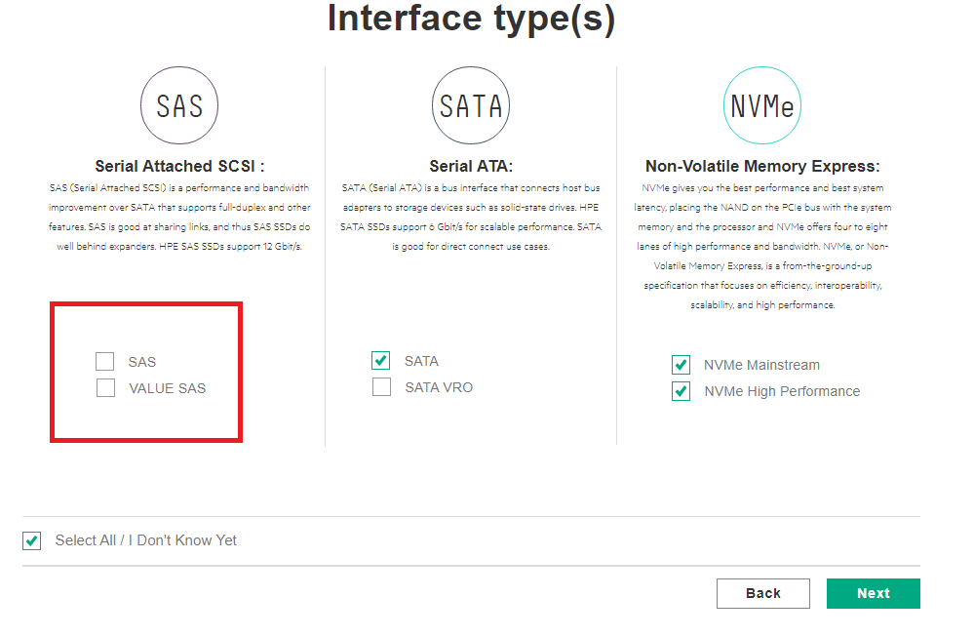

1. In Server Type page, without selecting the server Type, Next Button is enabled.

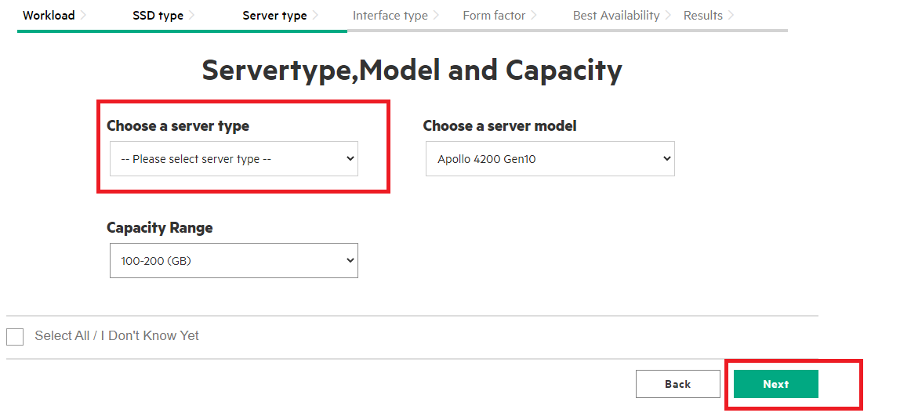

1. In Interface Page, though all options are not selected then also **“Select All / I Don’t Know Yet.”** Option is selected.

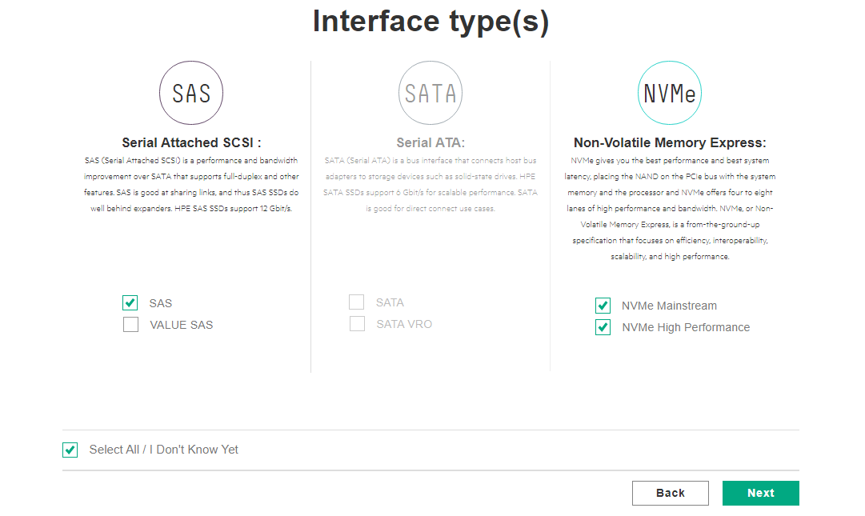

1. In Form Factor Page, though options are not showing then also Next button is showing.

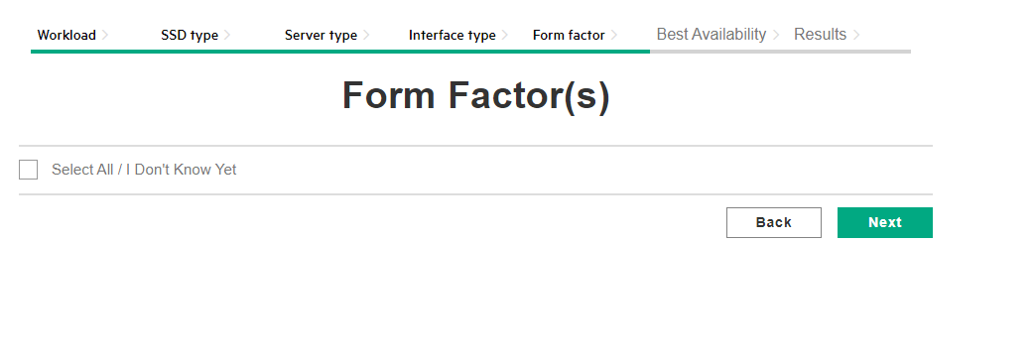

1. In Result page, SSDs results are displayed though options are not selected.

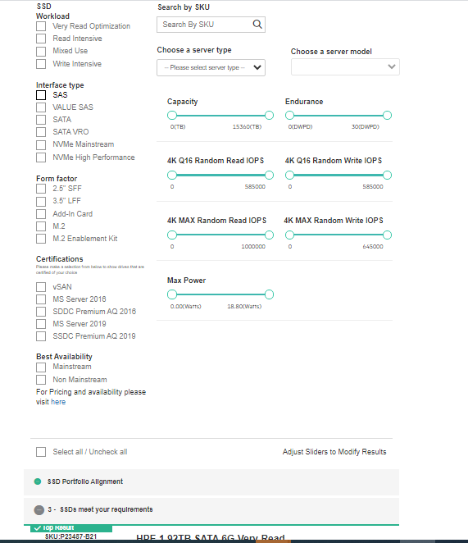

1. In Result Page, Mainstream and Non – Mainstream label is not showing in the SSD’s results.

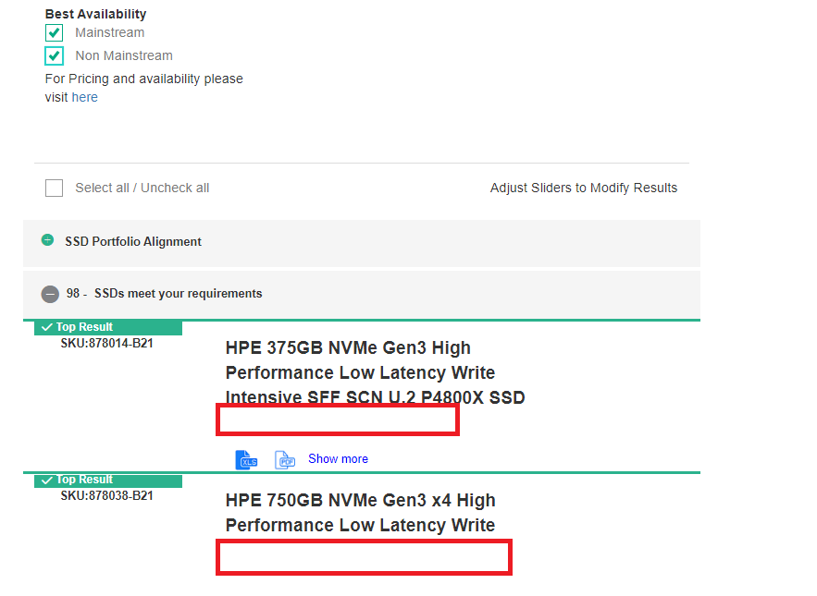

1. In Result Page, Semicolon are showing twice, in show more option.

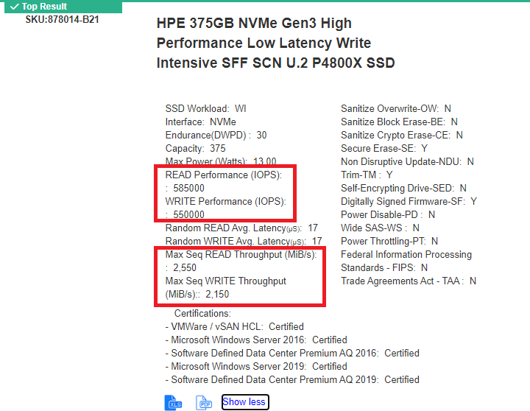

1. In Result page, Moving the slider from Max to Min, then SSDs results are not change.
2. For VRO Workloads, though Capacity is selected with “**300 GB to 400 GB**”, in the result page it shows “**0TB to 1530TB.”**

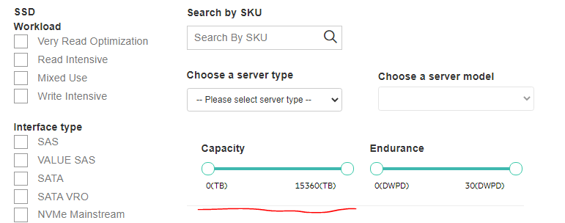

1. In Result Page, though “**Read Intensive/Write Intensive/Mixed Use**” option is selected, but all SSD’s results are displayed with Mixed and Write.

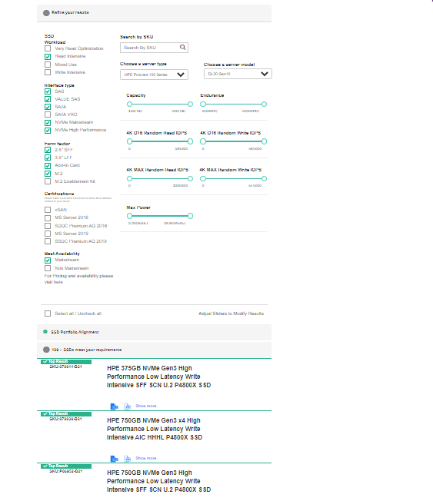

1. In Result Page, click on “**Select All/Uncheck All**”, then different set of SSDs are displayed.

Before Clicking on “Select All/Uncheck All”

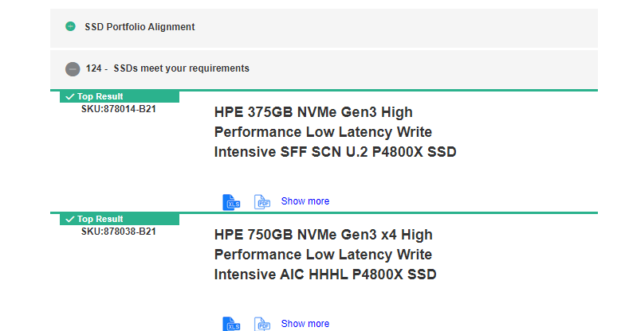

After Click on “Select All/Uncheck All”

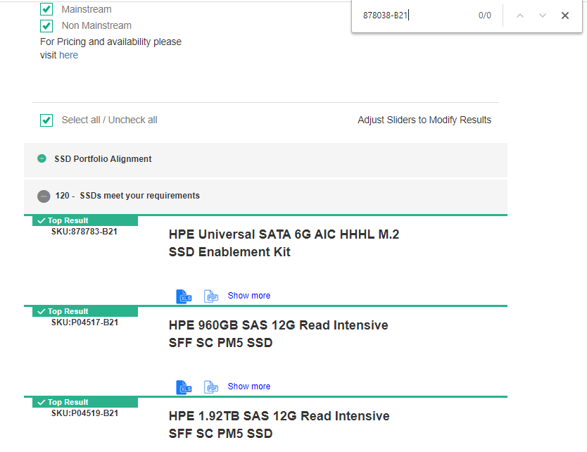

1. In Result Page, SSDs results are not displayed based on the SSD Workload, Interface, Form Factor filter
2. In Result Page, though SSDs results are available, “0 – SSDs meet your requirements” message is displayed,
   1. In result page, In search for invalid SKU in “Search Tab”
   2. In search Tab, enter the invalid SKU number,
   3. Then click on Search icon, then Correct error Message is displayed,
   4. Erase the invalid SKU Number in search tab, then, “0 – SSDs meet your requirements” message is displayed.

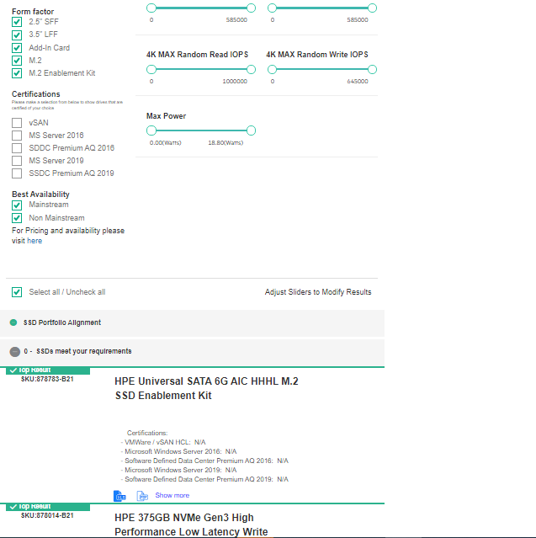

1. In Result page, options are unchecked mode, can click the check box.
2. In Excel file, Performance Columns name should be as shown below,

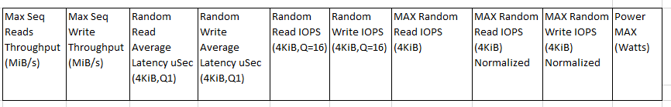

But it is like this,



1. In Workload Page, “To Learn More About Workloads Click Here” link is redirecting to Not Found page,
2. Excel file should be in below format,

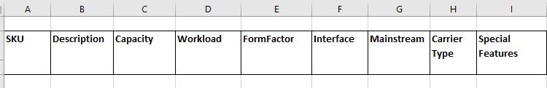

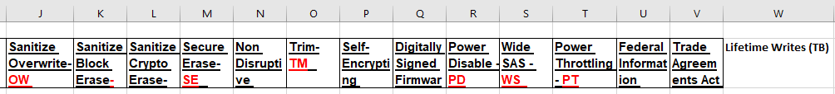

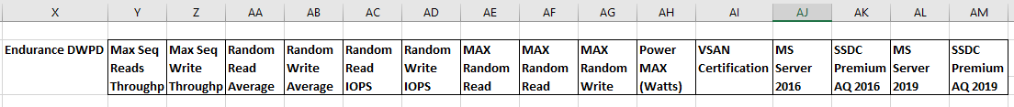

15th-March-2021

1. In Result Page, In the Capacity Slider, Slide the Max point to Min, less than 100, then SSDs results are displayed more than the Slider Capacity value.

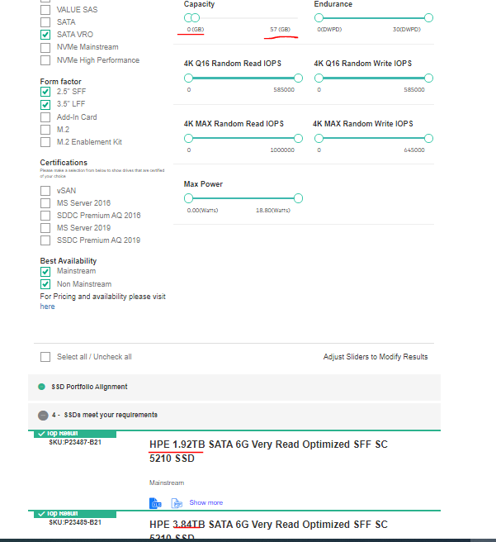

1. Selected values Server type, Server Model and Capacity Values will not be retained on back button in the interface page

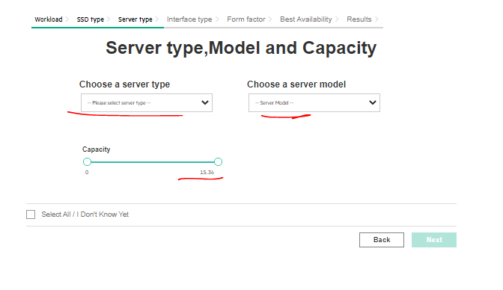

1. In Export Excel and Export CSV file, need to add the 4 more columns such as

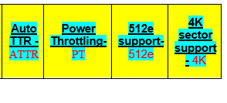

1. In Result Page, if Maximum Capacity slider value is in TB (15.36 TB), Unable to Slider less than 1TB.
2. In Result Page, 309 SSDs should be displayed, but 201 SSDs are displayed.
3. In Result Page, In Search Tab, Enter the invalid SKU Number and click on Click on Search Icon, Then Alert Message is displayed,

“There are no results based on your selection. Please select different attributes or start over.”

Then Remove the SKU Number, then SSDs results are not shown same message is displayed.

“There are no results based on your selection. Please select different attributes or start over.”

17th Issues

1. Remove the Special Characters in the SSD Description

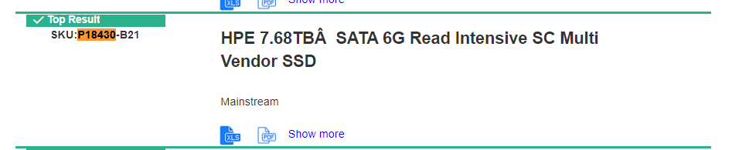

1. Select All in all the pages then also “Value SAS” is not enabled in the Interface Page.

* Click on “Select All” option in Workload Page and Click on “Next” Button
* Click on “Next” Button, in SSD page,
* In Server type page, click on “Select All” Option and Click “Next” Button in Server Type Page,
* In Interface Page, “Value SAS” is not enabled, though all options are selected in previous pages.

1. Select All option will be deselected on click on “Back” Button in Interface Page.

* Click on “Select All” option in Workload Page and Click on “Next” Button
* Click on “Next” Button, in SSD page,
* In Server type page, click on “Select All” Option and Click “Next” Button in Server Type Page,
* In Interface Page, click on Back,

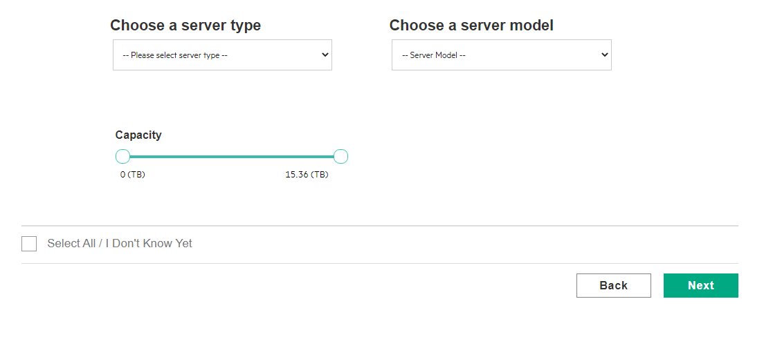

1. If Select All option is selected in Server Type page, then Capacity Part should be in disabled State,

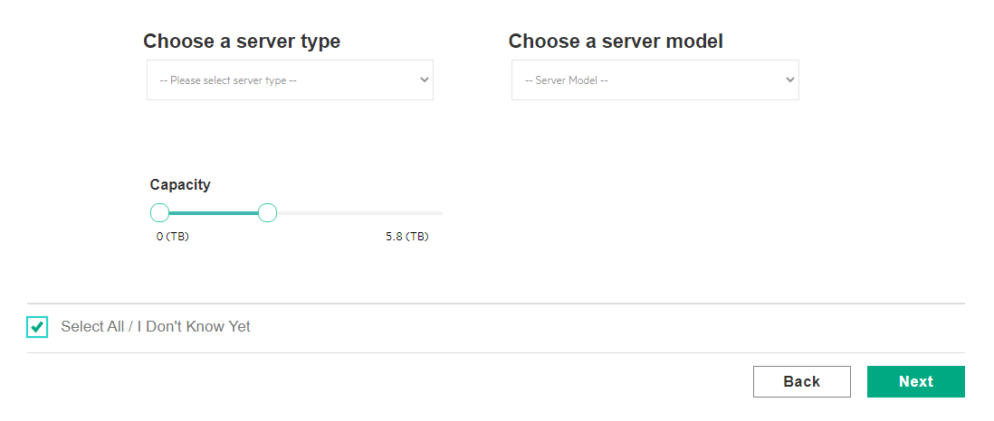we can move the slider and reached to result page, In Result Page, Selected Value will be shown in the result page,

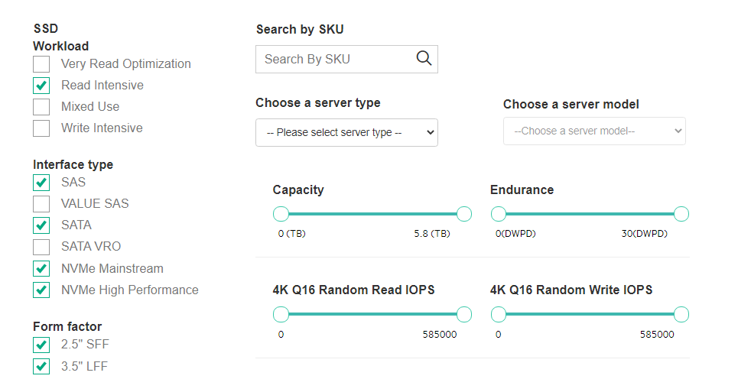

1. In Excel File, the Header should be “High Power SAS- HPS”, but it is showing like this

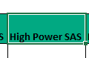

1. In Interface face Page, “Value SAS” is in disabled state, though selected workloads support for the “Value SAS”

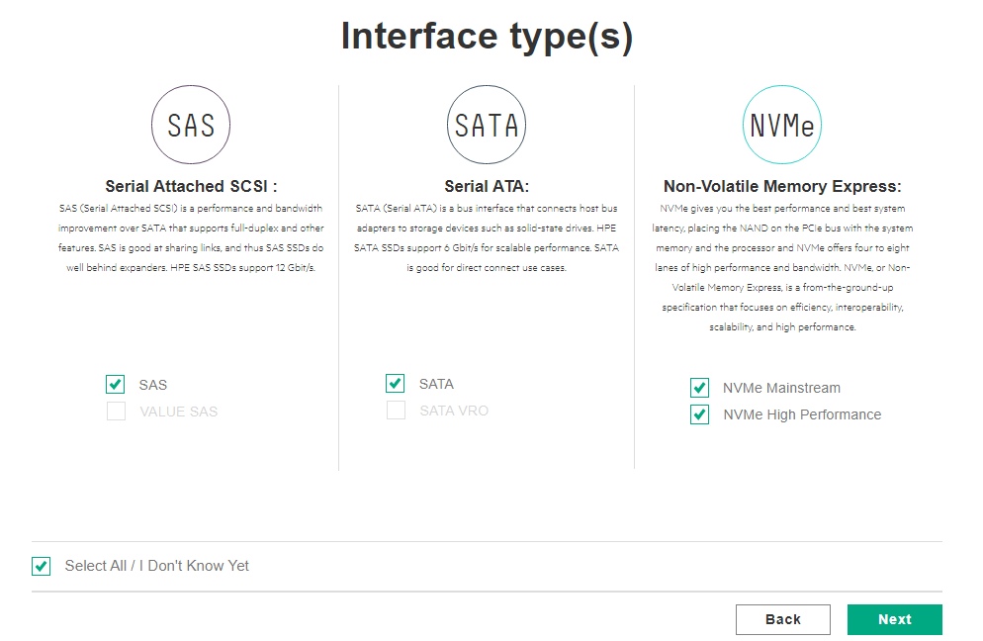

1. In Result page, Price Link is redirecting to Bad Gateway

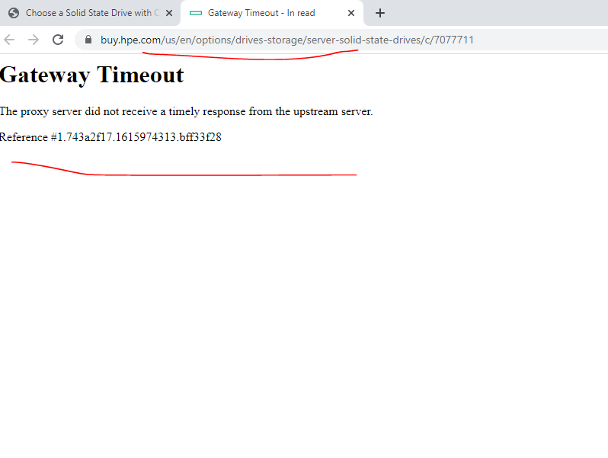

1. In Result page, Slider’s values are changes on moving the maximum points

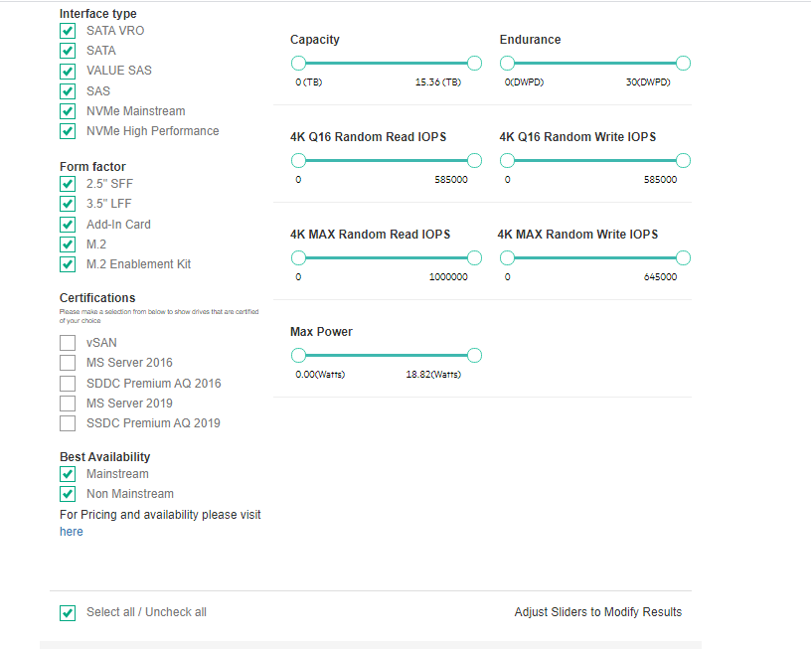

* Click on “Select all/Uncheck All” option in Result page,
* Then Slider part, Slide the “4K Q16 Random Read IOPS”, “4K Q16 Random Write IOPS” and “Max Power” sliders,
* Maximum values changes

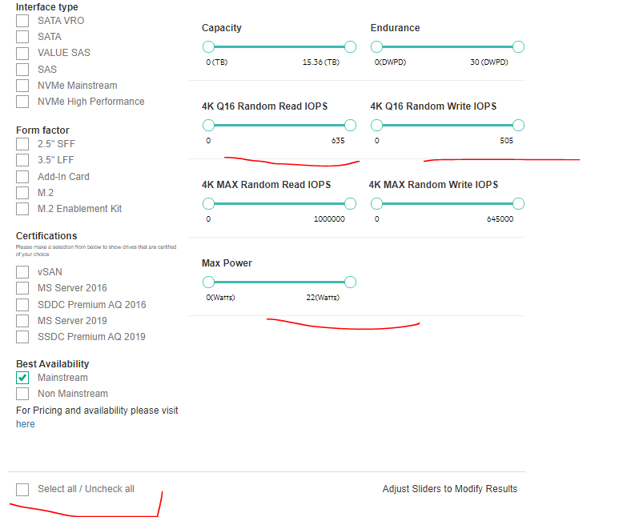

1. In the Individual Export Excel file, “Special Feature’s” Column should be removed. And need to add the suggested Column.

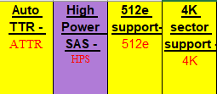

1. Selected values in Server type page for Capacity Values will not be retained on back button in the interface page

Selected Capacity Value and clicked on Next Button

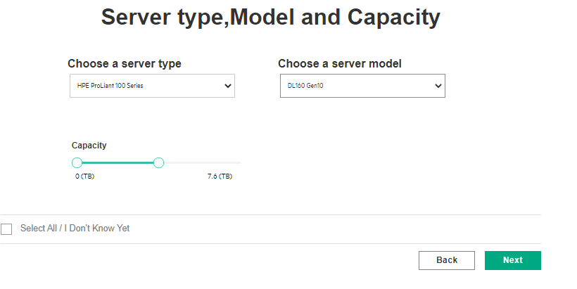

Click Back button in Interface Page,

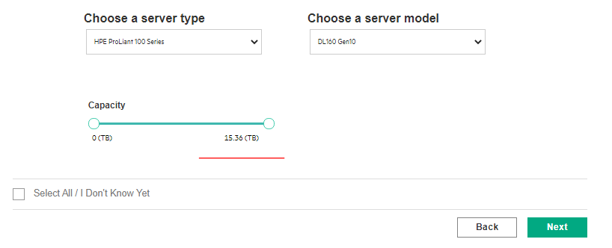

1. In Result page, Capacity Slider’s values are changes, 0 TB to 15.36 TB to 0 GB to 15360 TB,

* Click on “Select all/Uncheck All” option in Result page,

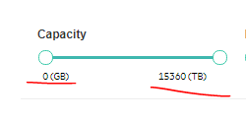

1. SSD Home Page, unable to click on “Mouse Over” pop up.

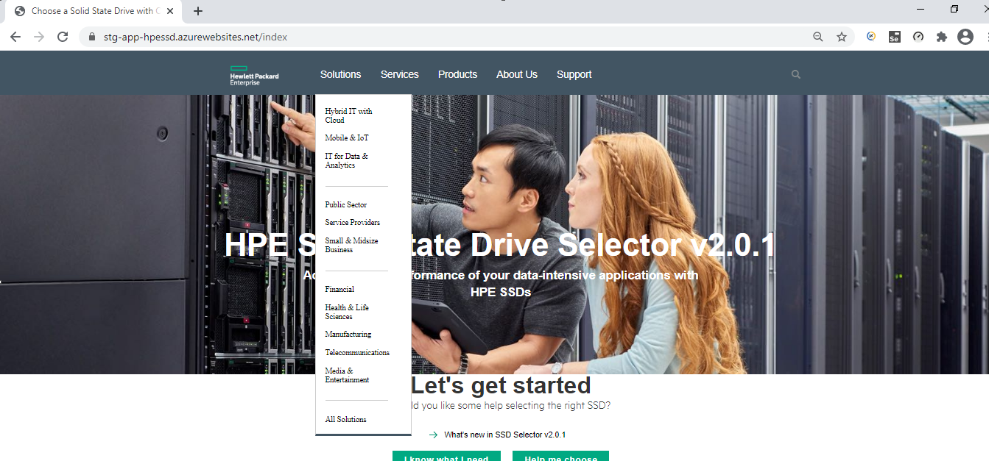

1. After deselecting the Server Type and Server Model, Then Next gets disabled.
   1. Select any workload and reach to Server Type Page.
   2. Deselect the “Select All/I Don’t Know Yet” option in Server type Page
   3. Select the Server type and Select the Server Model
   4. Then Deselect the Server Model. Then Next Btn gets disabled.

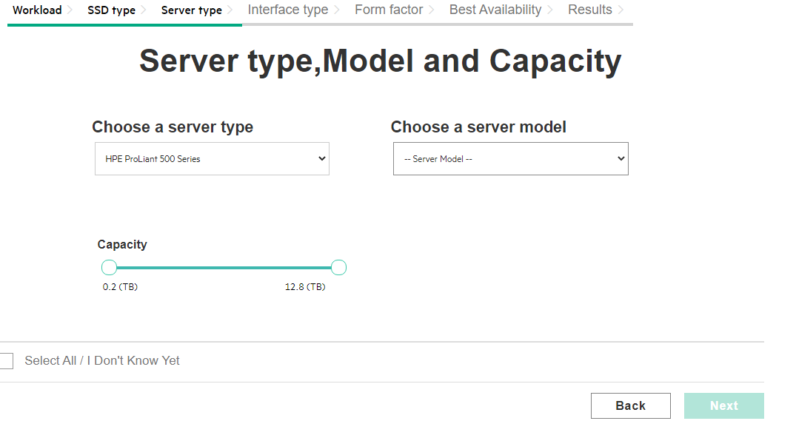

1. With Server Model can reach to Result Page
   1. Select any workload and reach to Server Type Page.
   2. Deselect the “Select All/I Don’t Know Yet” option in Server type Page
   3. Select the Server type and Select the Server Model
   4. Click on Next Button.
   5. Interface Page, Click Back Button
   6. In Server type page, click on Server Type and Select the “please Select Server type” option from drop.
   7. Then in Server Model Tab, gets empty.

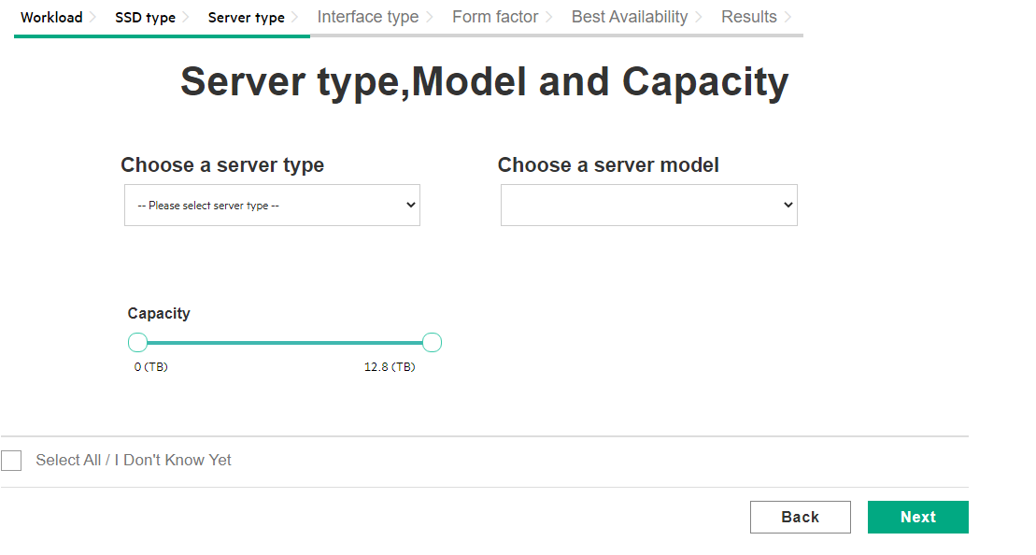

1. Though Single workload is select in Workload page, then also “Select All/I Don’t Know Yet” option is selected. In Server type page

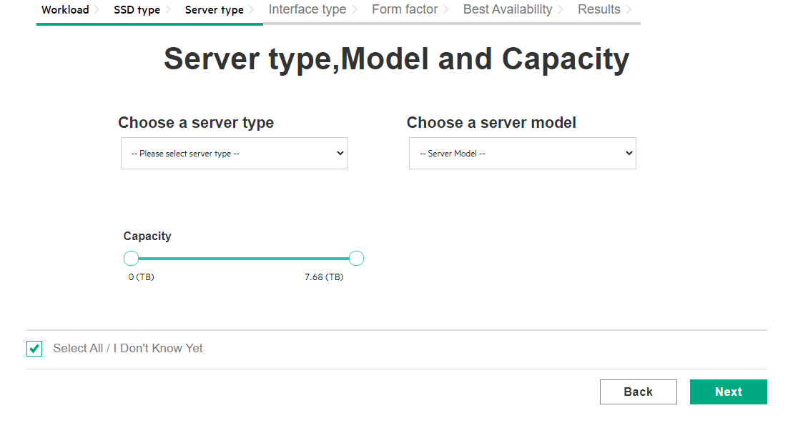

1. Without selecting Form Factor, SSDs Results are displayed
   1. Select any workload and reach to Server Type Page.
   2. Deselect the “Select All/I Don’t Know Yet” option in Server type Page
   3. Select the Server type and Select the Server Model
   4. Click on Next Button.
   5. Interface Page, Click Back Button
   6. In Server type page, click on Server Type and Select the “please Select Server type” option from drop.
   7. Then in Server Model Tab, gets empty.
   8. Click on Next Button
   9. Interface Types are displayed then click on Next in Interface Page,
   10. Then in Form Factor Options are not Displayed, then also Next Button is enabled.

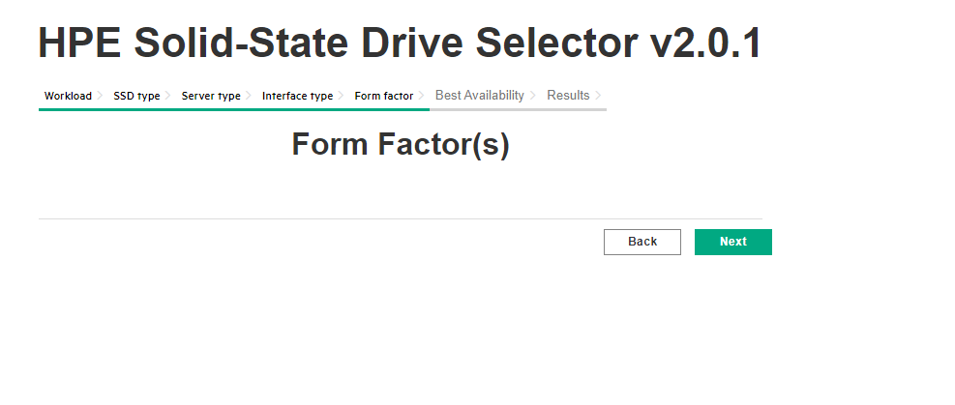

* 1. In Result page, With Form Factor selecting SSDs are displayed

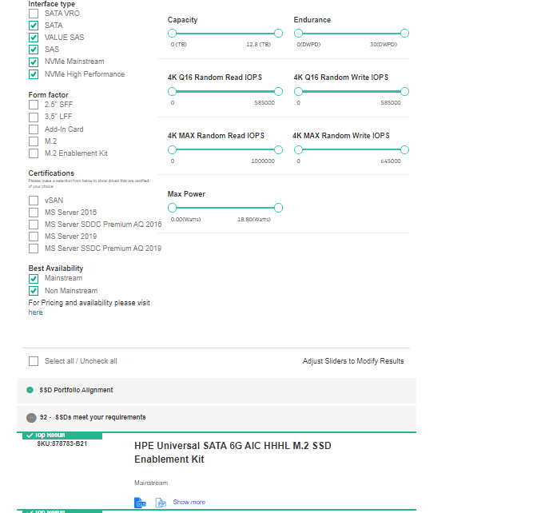

1. Zero SSDs are displayed in Result page, with selection of Server type in Server Type page.
   1. Select any workload and reach to Server Type Page.
   2. Deselect the “Select All/I Don’t Know Yet” option in Server type Page
   3. Select the any Server type,
   4. Then Next Button in remaining pages,
   5. In Result page, “0” SSDs are displayed.

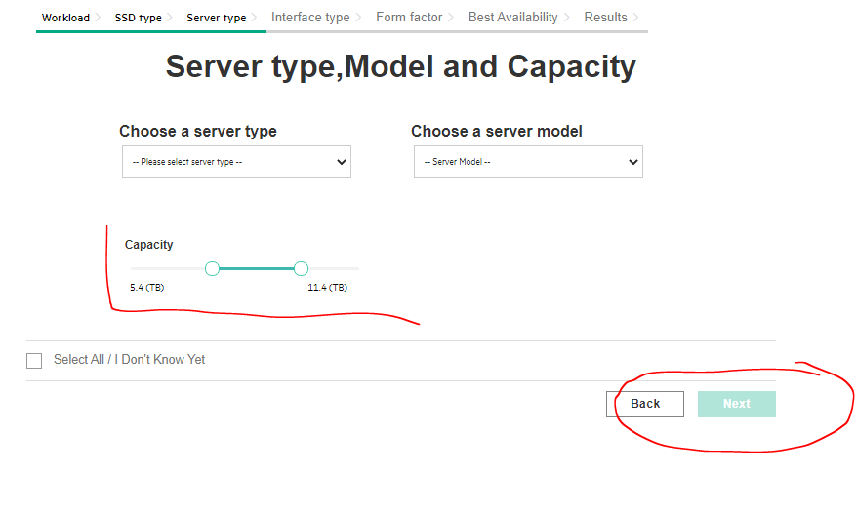

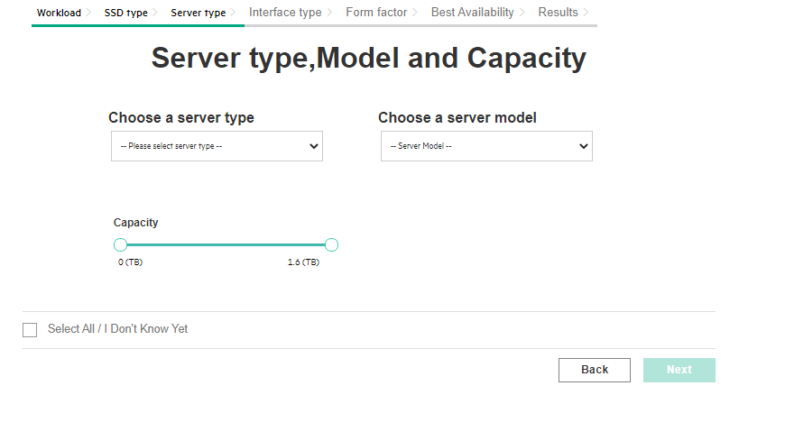



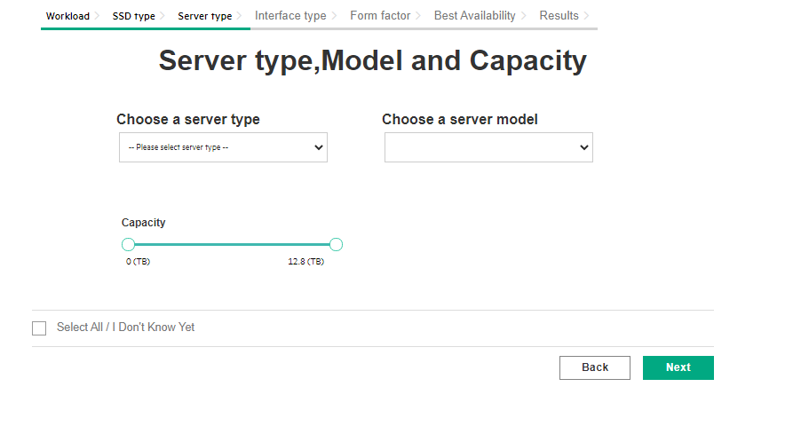



06th April

1. Server Type Value will be empty, On Click on Back Button in the Interface Page. 🡪 Fixed
   1. Select any workload and reach to Server Type Page.
   2. Click on Next Button.
   3. Interface Page, Click Back Button

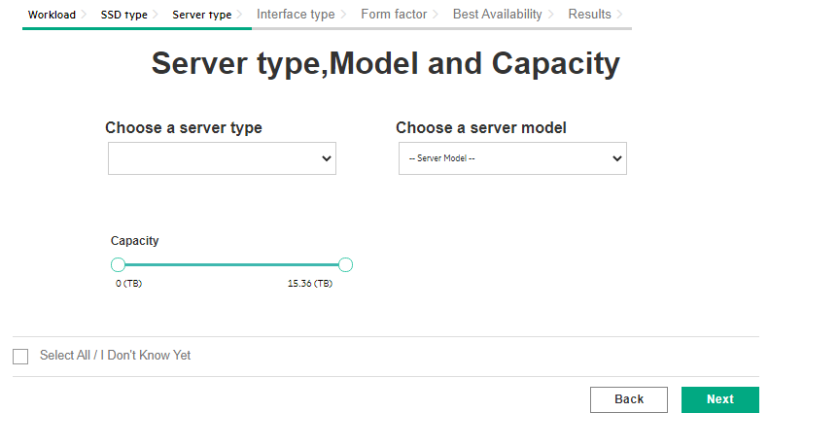

1. In the Sever Type Page, “Deselected Value” will not be retained.
   1. Select any workload and reach to Server Type Page.
   2. Deselect the “Select All/I Don’t Know Yet” option,
   3. Click on Next Button.
   4. Interface Page, Click Back Button
   5. Then in the Server Type Page, “Select All / I Don’t Know Yet” is Selected.

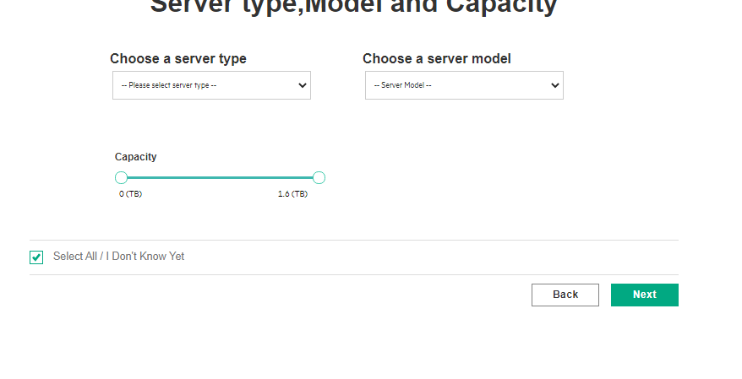

1. In the Show More Section, “4K Sector Support” Show twice.

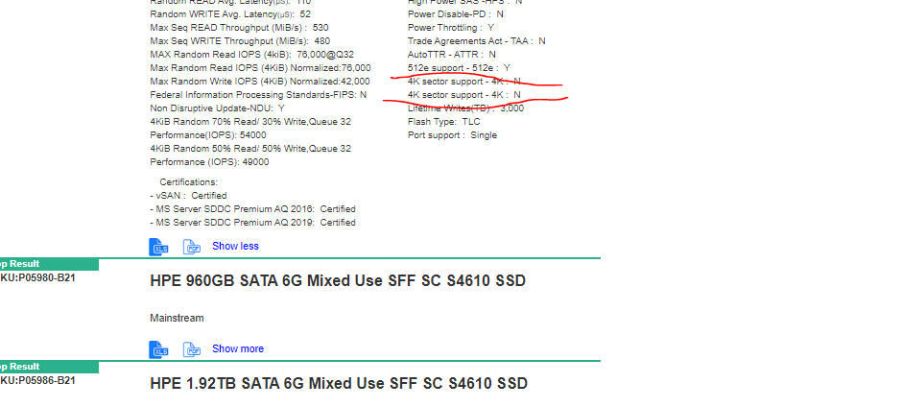

1. For Read Intensive SSDs, In the Show More Section, Some Label value are showing with “?”

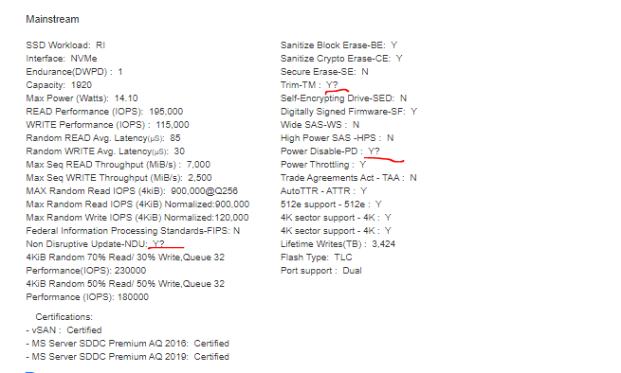

1. For Individual Excel Download, for “Auto TTR-ATTR”, “512e Support” and “4K sector Support” columns value is showing empty.

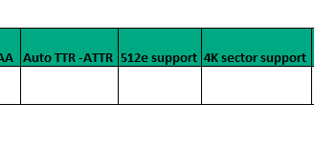

Today Issues on 15th April 2021

1. Slider is retained but both Min and Max Value Changed to 2.2 TB to 0TB (Min Point) and 8 TB to 15.36 TB (Max Point)
   1. Select any workload and reach to Server Type Page.
   2. Deselect the “Select All/I Don’t Know Yet” option,
   3. Select the Sever Type and Server Model
   4. In Capacity Slider, Move the Max Point from 15.36 TB to 11.2 TB or any other value and Move the min Point from 0 TB to 2.8 TB

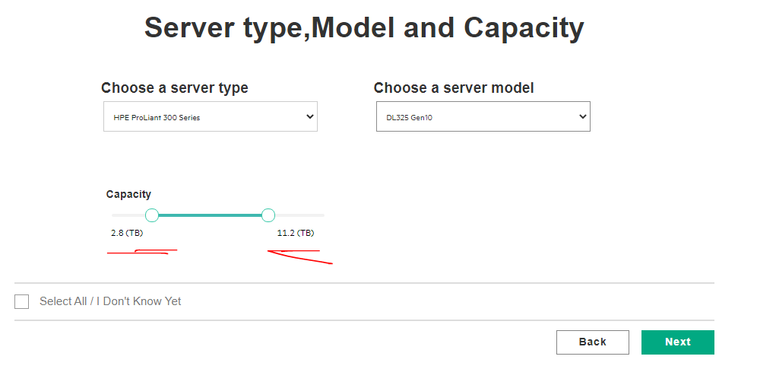

* 1. Next Button in Server Type page,
  2. Click Back Button in Interface Page.
  3. Then Selected value will not have retained, it changed to Max Point Value and Changed to Min Point Value.

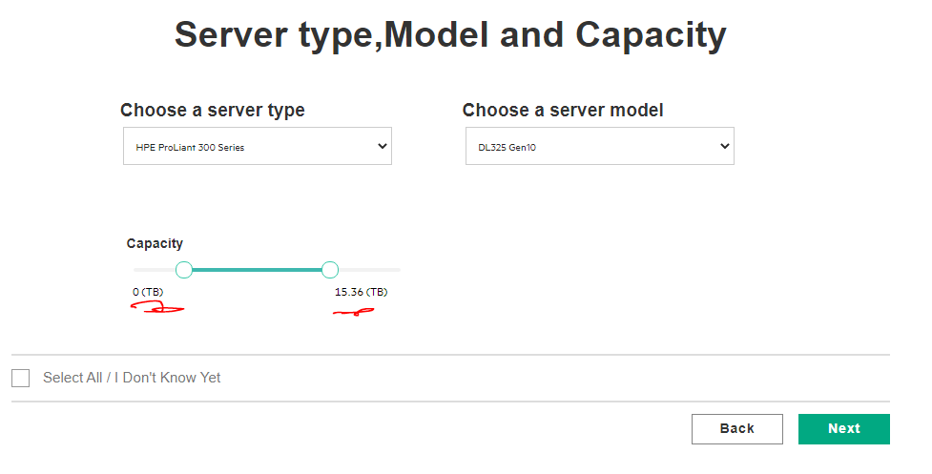

1. Slider is retained, Minimum value point changed 3.6 TB to 0 TB.
   1. Select any workload and reach to Server Type Page.
   2. Deselect the “Select All/I Don’t Know Yet” option,
   3. Select the Sever Type and Server Model
   4. In Capacity Slider, Move the Min Point from 0 TB to 3.6 TB or any other value,

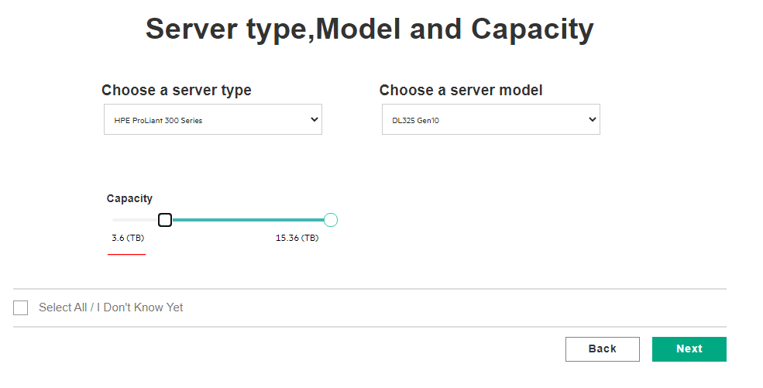

* 1. Next Button in Server Type page,
  2. Click Back Button in Interface Page.
  3. Then Selected value will not have retained, it changed to Min Point Value, as 0 TB

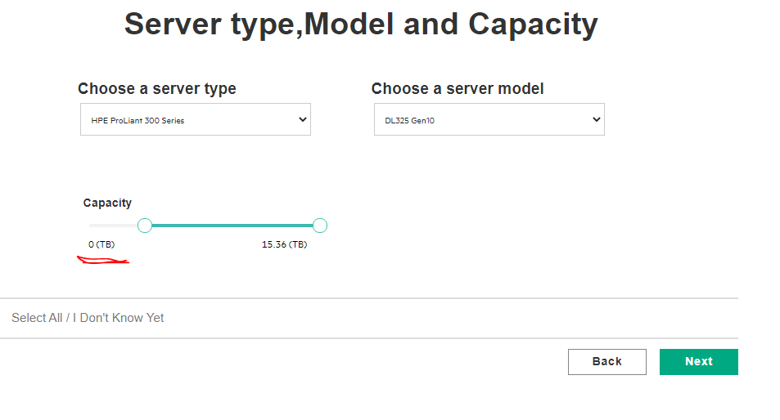

1. Slider is retained, Maximum value point changed 7 TB to 15.36 TB.
   1. Select any workload and reach to Server Type Page.
   2. Deselect the “Select All/I Don’t Know Yet” option,
   3. Select the Sever Type and Server Model
   4. In Capacity Slider, Move the Max Point from 15.36 TB to 7 TB or any other value,

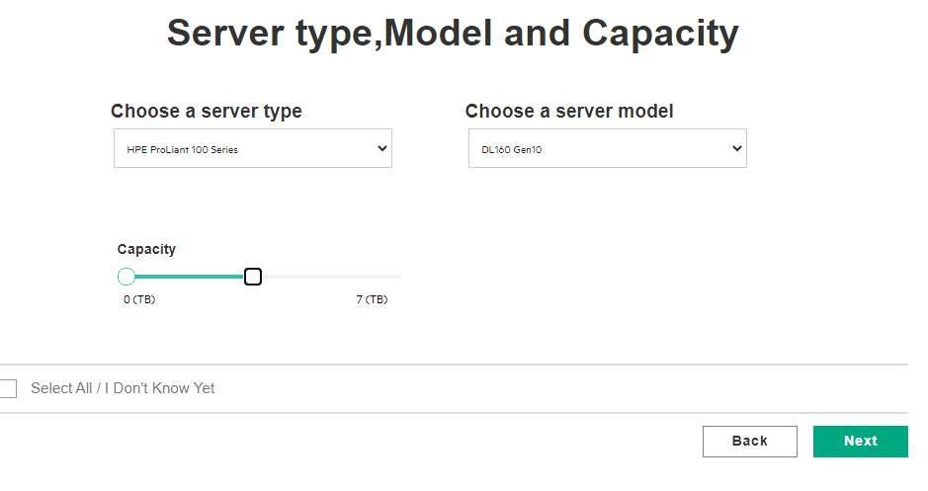

* 1. Next Button in Server Type page,
  2. Click Back Button in Interface Page.
  3. Then Selected value will not have retained, it changed to Max Point Value,

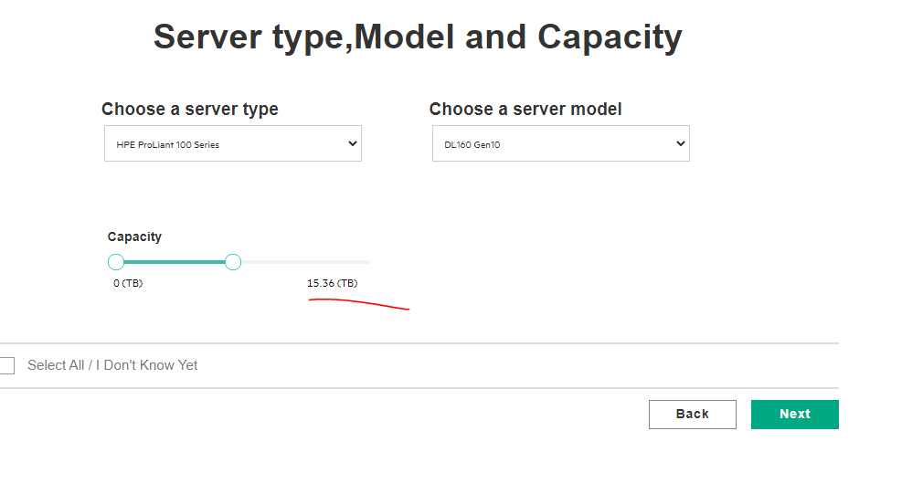

1. For Individual in Export Excel file, Export Date is not showing



1. For Individual Export Excel file, for “MAX Random Read IOPS(4KiB)” and “Max Random Write IOPS (4KiB), Data is not showing in file,

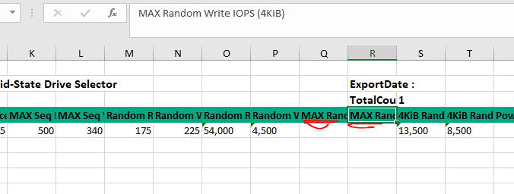

In Result Data Is showing

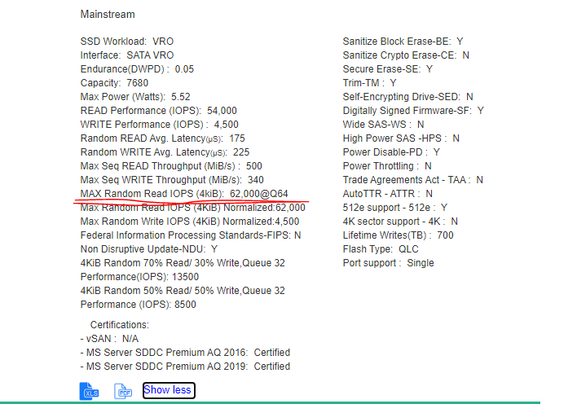

1. Small correction in the Label for “MAX Random Read IOPS(4kiB)” , in Label K should be in Capital letter, as “**MAX Random Read IOPS(4KiB)**”

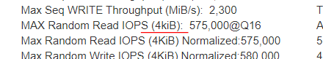

1. In PDF file also changes should see with respect to 1000 separation by “,”.



26th April 2021

1. Server Model Value will be empty, On Click on Back Button in the Interface Page.
   1. Select any workload and reach to Server Type Page.
   2. Select the Server Type from the drop.
   3. Click on Next Button.
   4. Interface Page, Click Back Button

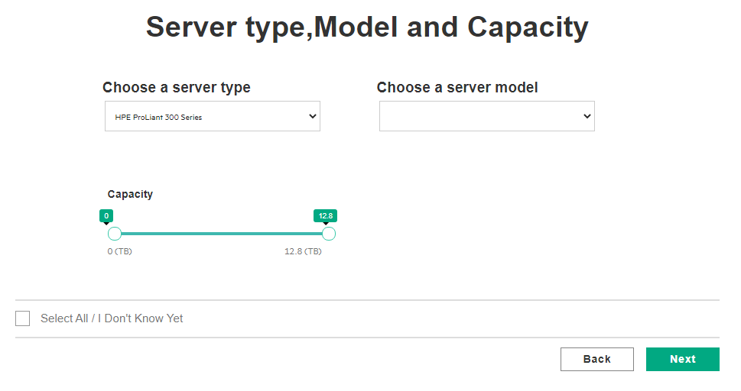

1. Form Factors options will not be seen, when Server Model is null,

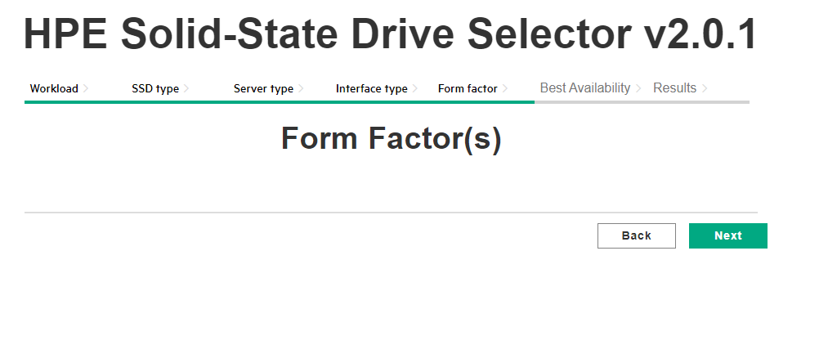

1. In Result Page, Capacity Max value will be changed, when maximum point will be moved to the Maximum point,

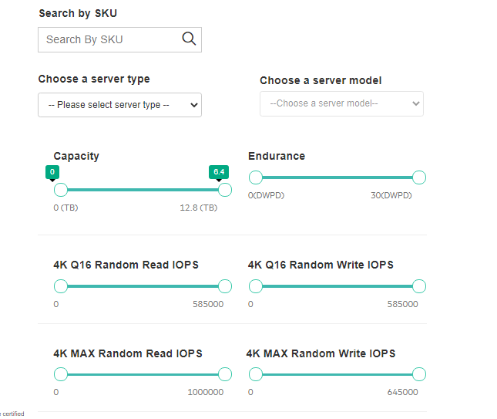

1. Maximum Tool Tip slide to last value. Then Maximum value changed from 12.8 (TB) to 6.4 (TB).

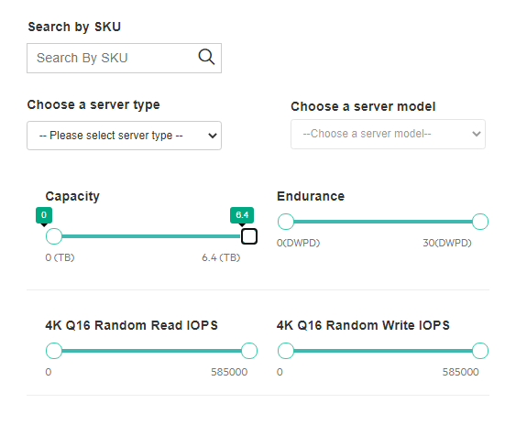

1. In the Result Page, Capacity Maximum Value Tool Tip is shown to Max Power Slider, on mouse over to Max Power Maximum Point.

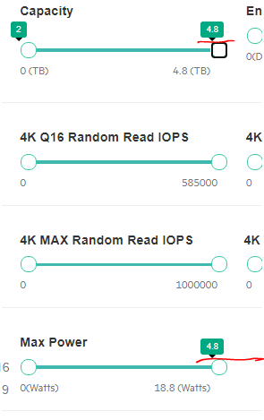

1. In Result Page, After Click on “Select All/UnCheck All” option, then Selected Maximum Tool tip is showing in the Capacity Slider
   1. Select any workload and reach to Server Type Page.
   2. Select the Server Type and Server Model from the Drop down,
   3. In Capacity Slider, Slide the Maximum Point and Min Point

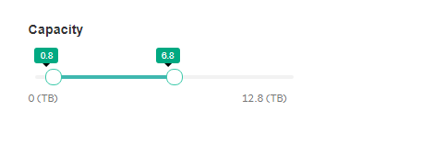

* 1. Click on Next Button in remaining Page,
  2. In Result Page, SSDs results are displayed based upon the selection.

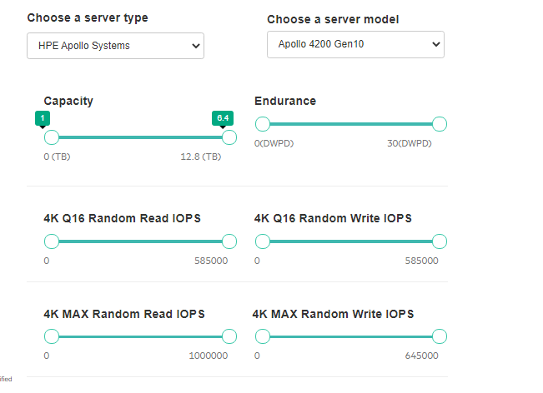

* 1. Click on “Select All/Uncheck All” option then SSDs and Capacity Maximum Value changed but Maximum and Minimum Tool Tip are not changed

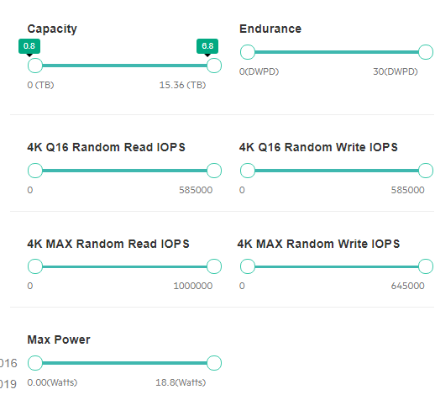

1. In Result page,In Capacity Slider, Move the Maximum Point, Capacity Value Changes but Maximum Tool Tip Remains as it is.
   1. In Home Page, Click on “I Know What I Need” Option
   2. In Result Page, I Capacity Slider, Move the Maximum Point, Capacity Value Changes but Maximum Tool remains static

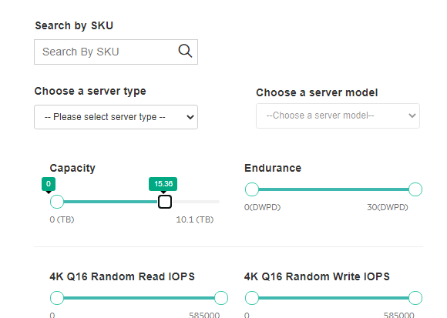

29-April-2021

1. In Result page, After reset (Select All/ UnCheck All), Tool Tip remains same with respect to Minimum and Maximum.

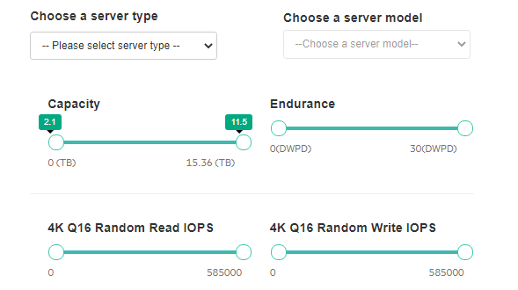

* In Home Page, Click on “I Know What I Need” Option,
* In Result Page, SSDs result are displayed
* Then In Capacity Slider, Move the Slider form Minimum Point and Maximum Point

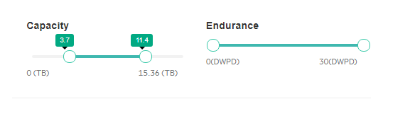

* Then Click on “Select All/UnCheck All” .
* In Capacity Slider, Minimum and Maximum Point will be reset, But Tool tip will not will be reset.

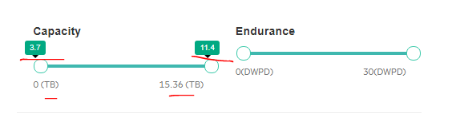

But All SSD results are displayed.

1. When Capacity Slider is at 0 Point (Maximum Point to Minimum Point), Then Retaining slider value is not happening, on Click on Back Btn in Interface Page,

a. Select any workload and reach to Server Type Page.

b. Select the Server Type and Server Model

c. In the Capacity Slider, Move the Maximum Point to Minimum point (I Mean Capacity Slider Value is 0 TB)

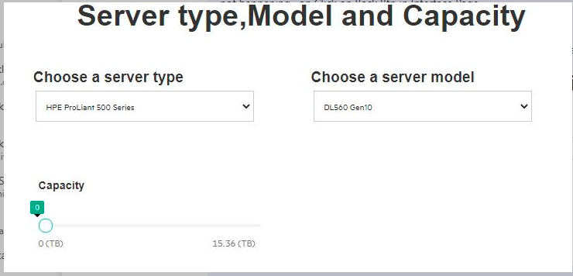

d. Then Click on Next Btn,

Actually Alert Message should come. (It is not Coming)

e. In the Interface Page, Click on Back Btn.

Then Capacity Slider, is not retained, but it moved to 0 TB to 15.36 TB

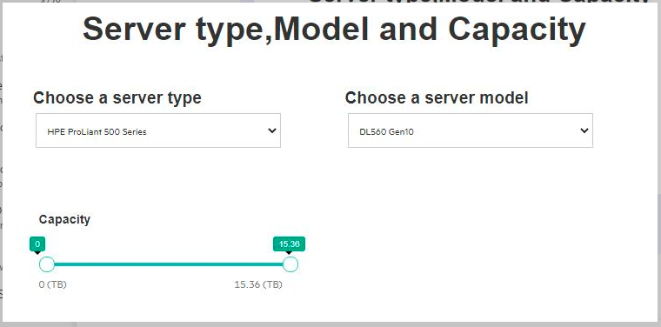

1. Unable to find the Minimum Point, On Click on Back Btn in Interface Page

a. Select any workload and reach to Server Type Page.

b. Select the Server Type and Server Model

c. In Capacity Slider, Move the Minimum Point to Maximum Point (I mean 0TB to 15.36TB)

d. Then Click on Next Btn,

e. In Interface page, Click on Back Button,

f. Then in Capacity Slider, Unable to find or Move the Minimum Point

1. Server Type gets disables,

a. Select any workload and reach to Server Type Page.

b. In Server Type Page, by default "Select All /I Don't Know Yet" Option is Selected

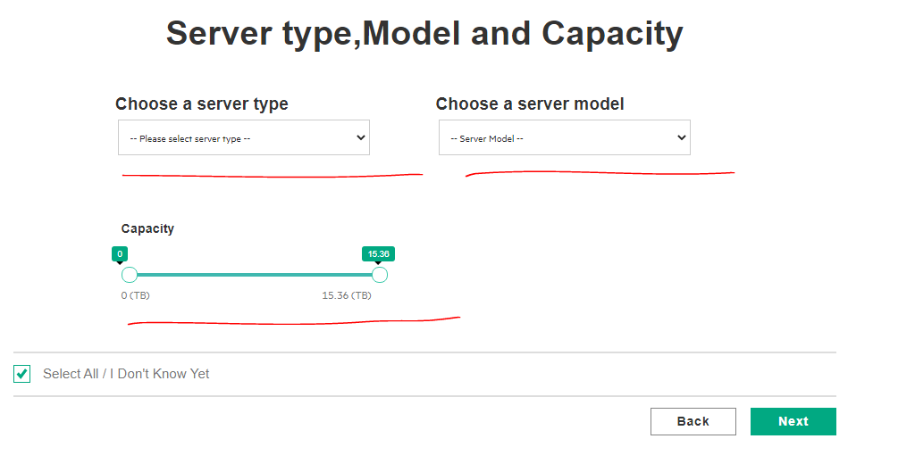

* 1. Click on "Select All/ I Don't Know" Option,
  2. Again Click on "Select All / I Don't Know Option”,
  3. Then Server type and Server Model Drop down gets disabled

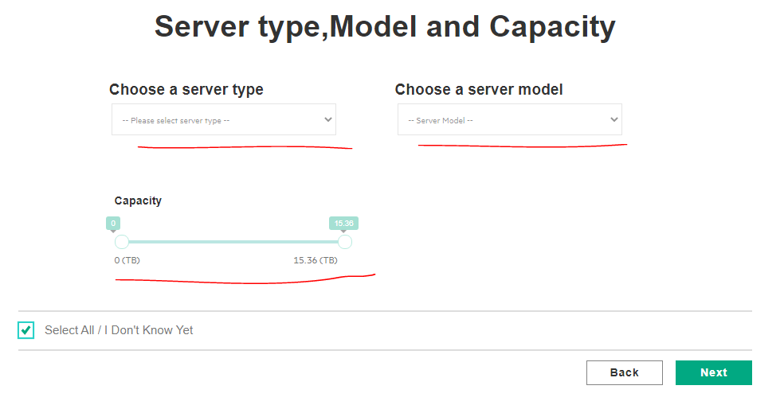

Today’s Status

|  |  |  |  |  |
| --- | --- | --- | --- | --- |
| S/No. | Description | Status | Remarks | Status on 05/05/2021 |
| 1 | In Export Excel, Export CSV and Result display  “?” character is showing | Fail | For example SKUs Numbers are P22276-B21,P22282-B21 | Fixed  On 04-May-21 |
| 2 | In Result Page, if we Select the Server Type and Click on Export Excel, File will be downloaded with empty content and in Result Page, 140 SSDs are showing but in Excel file, "0" | Fail |  | Fixed |
| 3 | Unable to find the Minimum Point, On Click on Back Btn in Interface Page  a. Select any workload and reach to Server Type Page.  b. Select the Server Type and Server Model  c. In Capacity Slider, Move the Minimum Point to Maximum Point (I mean 0TB to 15.36TB)  d. Then Click on Next Btn,  e. In Interface page, Click on Back Button,  f. Then in Capacity Slider, Unable to find or Move the Minimum Point | Fail | Unable to edit |  |
| 4 | Server Type gets disables,  a. Select any workload and reach to Server Type Page.  b. In Server Type Page, by default "Select All /I Don't Know Yet" Option is Selected  c. Click on "Select All/ I Don't Know" Option  d. Again Click on "Select All / I Don't Know Option”,  Then Server type and Server Model Drop down gets disabled | Fail |  | Fixed |
| 5 | In Export CSV File, |  | Double quotes are showing | Fail |
| 6 | Tool Tip has to be implemented for all Sliders. | Working on it | Need to implement | Fixed |
| 7 | In Mixed Use workload, In Capacity Slider, when Both Maximum and Minimum at “0 TB”. | Pass | Alert Message is displayed |  |
| 8 | For other workloads, Such as “**VRO, Read and Write Intensive**“, In Capacity Slider, when Both Maximum and Minimum at “0 TB”. | Pass | Alert Message is displayed |  |
| 9 | SKU’s 291 SSDs are displayed | Working Fine | EOL and SUS |  |
| 10 | VRO: - 8 SSDs  Read Intensive: - 135 SSDs  Mixed Use: - 129 SSDs  Write Intensive: - 19 SSDs | 291 SSDs are showing |  |  |
| 11 | SATAVRO: - 8 SSDs  SATA: - 81 SSDs  VALUE SAS: - 16 SSDs  SAS: - 64 SSDs  NVMe Mainstream: - 61 SSDs  NVMe High Performance: -61 SSDs | 291 SSDs are showing |  |  |
| 12 | 2.5” SFF: - 262 SSDs  3.5” LFF: - 13 SSDs  Add-In Card: - 4 SSDs  M.2: - 11 SSDs  M.2 Enablement Kit: - 1 SSDs | 291 SSDs are showing |  |  |
| 13 | Mainstream: - 116 SSDs  Non Mainstream: - 175 SSDs | 291 SSDs are showing |  |  |

Today Release

1. In Result Page, All Sliders Max and Min Tool Tip will be reset, On Click on “No” option in the Alert Message.
   1. Select any Workloads and reach to Server Type Page
   2. In Server Type page,
   3. Select the Server type and Server Model
   4. Select the Capacity Slider,
   5. And Next Button in remaining Pages
   6. In Result Page, SSD will be displayed.
   7. For Other Sliders, the Move Slider from Minimum point and Maximum point. As shown in the image

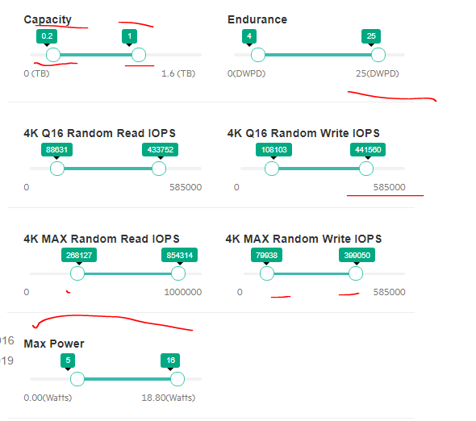

* 1. Then Click on “Select All/UnCheck All” option, In the Alert Message Select “No” Option. Then
  2. All Sliders will be reset though No Option is selected. Except Endurance Slider.

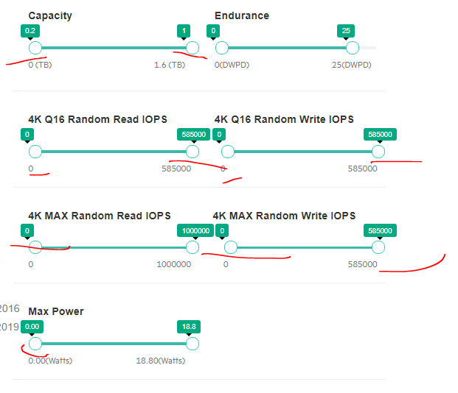

2. In the Export CSV File, Columns header is not there



3.

|  |  |  |  |
| --- | --- | --- | --- |
| S/No. | Description | Status | Remarks |
| 1 | Unable to find the Minimum Point, On Click on Back Btn in Interface Page  a. Select any workload and reach to Server Type Page.  b. Select the Server Type and Server Model  c. In Capacity Slider, Move the Minimum Point to Maximum Point (I mean 0TB to 15.36TB)  d. Then Click on Next Btn,  e. In Interface page, Click on Back Button,  f. Then in Capacity Slider, Unable to find or Move the Minimum Point | Fail | Unable to edit |
| 2 | In Export CSV File, | Fail | Double quotes are showing |
| 3 | In Result Page, All Sliders Max and Min Tool Tip will be reset, On Click on “No” option in the Alert Message.  a. Select any Workloads and reach to Server Type Page  b. In Server Type page,  c. Select the Server type and Server Model  d. Select the Capacity Slider,  e. And Next Button in remaining Pages  f. In Result Page, SSD will be displayed.  g. For Other Sliders, the Move Slider from Minimum point and Maximum point. As shown in the image | Fail |  |
| 4 | In the Export CSV File, Columns header is not there | Fail |  |
| 5 | In Export Excel, Export CSV and Result display  “?” character is showing | Pass |  |
| 6 | In Result Page, if we Select the Server Type and Click on Export Excel, File will be downloaded with empty content and in Result Page, 140 SSDs are showing but in Excel file, "0" | Pass |  |
| 7 | Server Type gets disables,  a. Select any workload and reach to Server Type Page.  b. In Server Type Page, by default "Select All /I Don't Know Yet" Option is Selected  c. Click on "Select All/ I Don't Know" Option  d. Again Click on "Select All / I Don't Know Option”,  Then Server type and Server Model Drop down gets disabled | Pass |  |
| 8 | Tool Tip has to be implemented for all Sliders. | Pass |  |
| 9 | In Mixed Use workload, In Capacity Slider, when Both Maximum and Minimum at “0 TB”. | Pass | Alert Message is displayed |
| 10 | For other workloads, Such as “**VRO, Read and Write Intensive**“, In Capacity Slider, when Both Maximum and Minimum at “0 TB”. | Pass | Alert Message is displayed |
| 11 | SKU’s 291 SSDs are displayed | Working Fine | EOL and SUS |
| 12 | VRO: - 8 SSDs  Read Intensive: - 135 SSDs  Mixed Use: - 129 SSDs  Write Intensive: - 19 SSDs | 291 SSDs are showing |  |
| 13 | SATAVRO: - 8 SSDs  SATA: - 81 SSDs  VALUE SAS: - 16 SSDs  SAS: - 64 SSDs  NVMe Mainstream: - 61 SSDs  NVMe High Performance: -61 SSDs | 291 SSDs are showing |  |
| 14 | 2.5” SFF: - 262 SSDs  3.5” LFF: - 13 SSDs  Add-In Card: - 4 SSDs  M.2: - 11 SSDs  M.2 Enablement Kit: - 1 SSDs | 291 SSDs are showing |  |
| 15 | Mainstream: - 116 SSDs  Non Mainstream: - 175 SSDs | 291 SSDs are showing |  |

May-27th-2021 Release on,

Icon and Description added in the Result page for each SKU’s

Issues

1. Icon and Description is not showing for these Labels such as
   1. Federal Information Processing Standard –FIPS
   2. Non-Disruptive Update
2. Description is not showing for this Label
   1. Trade Agreement Act
3. Though SSDs results are displayed, then also Loading icon is showing, it remains.
4. Unable to Download the Individual Excel and PDF file
5. Without Selecting the Server Type, Server Model List is displayed
   1. In Home Page, click on I Know What I Need
   2. Select any server Type
   3. Then SDDs results are loaded,
   4. Click on Reset Option, In Alert Message select Yes.
   5. Then SSDs are loaded correctly.
   6. Scroll up, In the Server Type drop down and Server Model drop down, should be in disable state.

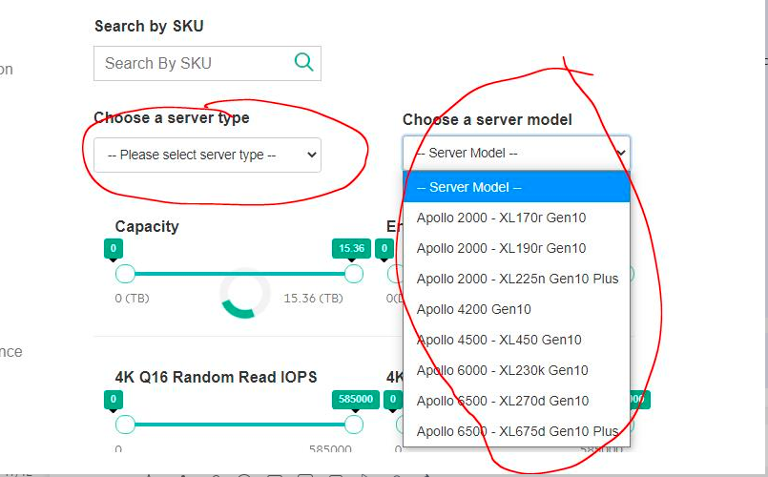

1. Server Type Pages values are not changed,
   1. In Home Page, click on Help Me Choose.
   2. In Workload Page, Select All workloads and Click next
   3. In SSD Type Page, all options are in Selected Mode, Click Next
   4. In Server Type Page, Select the Server Type and Server Model and Click Next
   5. In Interface Page, some options are in Selected Mode, deselect any one option and click Next
   6. In Form Factor Page, some options are in Selected Mode, deselect any one option and click Next
   7. In Best Availability Page, Click on Back Button,
   8. It redirect to Form Factor Page and Values are retained as we selected. Click on Back Button in Form Factor Page
   9. It redirects to Interface Page and Values are retained as we selected. Click on Back Button in Interface Page.
   10. It redirects to Server Type page, and Values are retained as we selected.
   11. Then Click Next Button in Server Type Page, Interface Page, Options values are changed.
   12. Click on Back Button in Interface Page. It redirects to Server Type page and Values are retained as we selected
   13. Click on Back Button in Server Type Page, It redirects to SSD Type page, and Values are retained as we selected.
   14. Click on Next Button in SSD type Page, it redirects to Server Type page and
       1. The Server Type -> value should change to -> “—Please Select Server type—
       2. The Server Model-> value should change to -> “—Server Model—
       3. Capacity Slider should be 0TB to 15.36 TB/12.8 TB/7.68 TB/ 3.6 TB
2. Server Type Pages, Max Tool Tip value and Max Value is different.

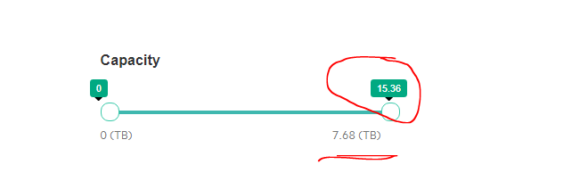

1. In Workload Page, Select All workloads and Click next
2. In SSD Type Page, all options are in Selected Mode, Click Next
3. In Server Type Page, Select the Server Type and Server Model and Click Next
4. In Interface Page, Click Back Button
5. In Server Type Page, Click Back Button
6. It redirects to SSD Type page, Deselect the Read Intensive, Mixed Use and Write Intensive, then click next button.
7. It redirects to Server type page, Then Max Tool Tip value and Max Value should be same.
8. Similarly, in SSD type page, Deselect the VRO, Read Intensive and Write Intensive, then click Next button.
9. Similarly, in SSD type page, Deselect the VRO, Read Intensive and Mixed Use, then click Next button.
10. Server Type Pages, Max Tool Tip value and Max Value is different.
    1. In Workload Page, Select All workloads and Click next
    2. In SSD Type Page, all options are in Selected Mode, Click Next
    3. In Server Type Page, Move the slider from Max Point to 9.4 TB. Then Click Next Button.
    4. In Interface Page, Click Back Button
    5. In Server Type Page, Click Back Button
    6. It redirects to SSD Type page, Deselect the Read Intensive, Mixed Use and Write Intensive, then click next button.

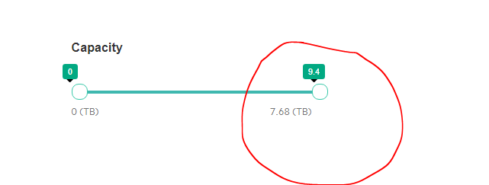

* 1. It redirects to Server type page, Then Max Tool Tip value and Max Value should be same.

1. SSD Home page, Unable to click on Popup overlay.
   1. In Home Page, Mouse over on the Solutions/Services/Products
   2. Popup overlay is opened, unable to select any option.

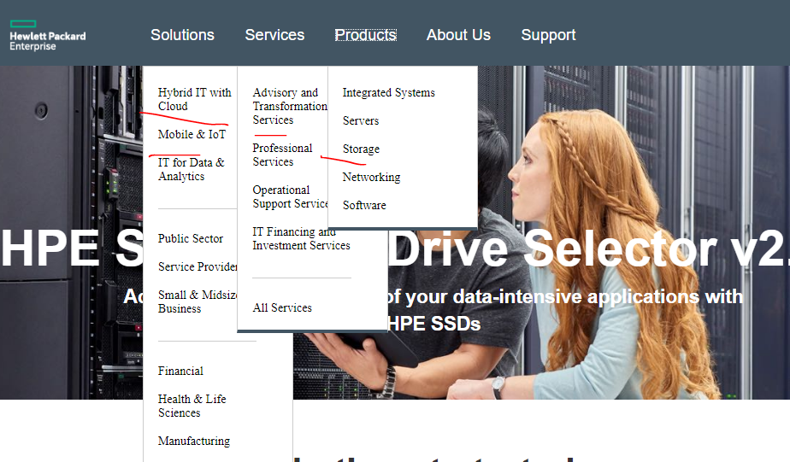

If we use the “tab” then works fine.

1. In Workload Page, click on “**Select All/I Don’t Know Yet**” option, Then All Workloads are selected,
   1. If we deselect any one column such as VRO/Read Intensive/Mixed Use/Write Intensive
   2. Then **Select All/I Don’t Know Yet**” option should deselect, but it is not deselected.

